cd ~/Desktop

mkdir gzip_test

pico myscript

-------------------------------- myscript -------------------------------

#!/bin/bash

# find all files created today, but not a .gz file nor myscript

# only take the last 2 files as example

LIST=$(find ~ -type f -daystart -ctime 0 -not -name "*.gz" -not -name "*myscript" | tail -2)

# loop to gzip the sample file to a .gz file and move them to a certain folder

for FILE in $LIST

do

gzip $FILE

mv $FILE.gz ~/Desktop/gzip_test

done

-------------------------------- myscript -------------------------------

EDITOR=nano /usr/bin/crontab -e

41 12 * * * sh ~/Desktop/myscript

echo "sample1" > s1.txt # create two files for examples

echo "sample2" > s2.txt

------------------------ Please find screen shot for results below -----------------------------

1. create a cron job

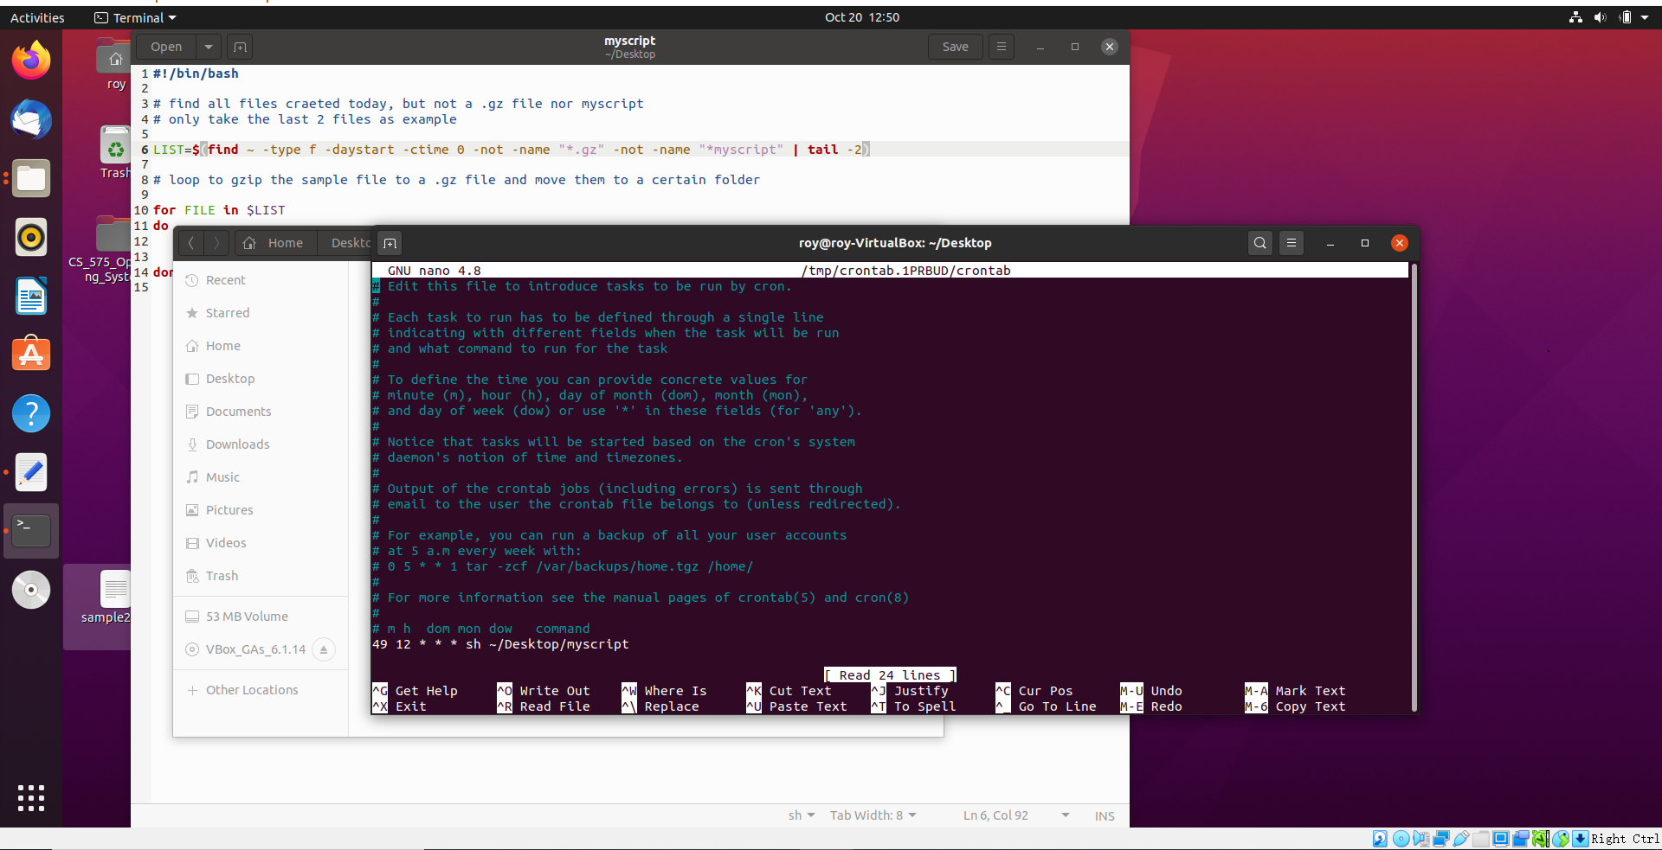

2. gz files appeared in the certain folder after the cron job got executed

